温湿度传感器
DHT11数字温湿度传感器是一款含有已校准数字信号输出的温湿度复合传感。它应用专用的数字模块采集技术和温湿度传感技术，确保产品具有极高的可靠性与卓越的长期稳定性。传感器包括一个电阻式感湿元件和一个NTC测温元件，并与一个高性能8位单片机相连接。该传感器的的温度测量范围为 0 ~ 50℃，误差为2℃；湿度测量范围为在0℃时为30%-90%，环境温度为25℃时，湿度测量范围为20%-90%RH，在50℃时，测量范围是20%-80%。
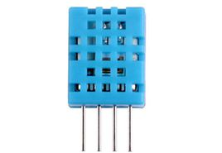
DHT11封装有4个引脚，各个引脚说明如下：
Pin | 名称 | 注释
1 | VDD | 供电 3-5.5 VDC
2 | DATA | 串行数据，单总线
3 | NC | 空脚
4 | GND | 接地，电源负极

原理图
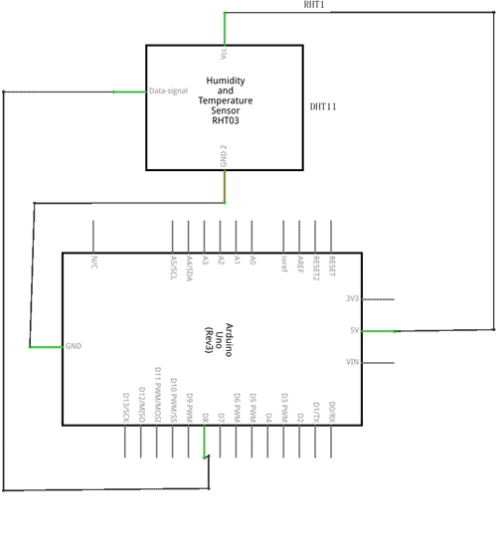

实物连接图
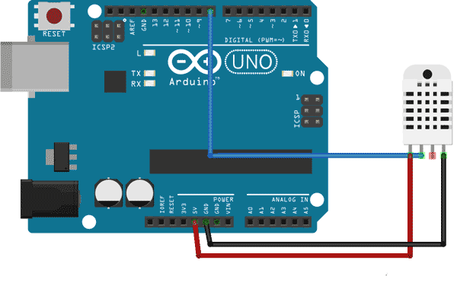

程序
下面的程序通过串口输出当时的温度和湿度：
double Fahrenheit(double celsius)
{
return 1.8 * celsius + 32;
} //摄氏温度度转化为华氏温度

double Kelvin(double celsius)
{
return celsius + 273.15;
} //摄氏温度转化为开氏温度

// 露点（点在此温度时，空气饱和并产生露珠）
// 参考: http://wahiduddin.net/calc/density_algorithms.htm
double dewPoint(double celsius, double humidity)
{
double A0= 373.15/(273.15 + celsius);
double SUM = -7.90298 * (A0-1);
SUM += 5.02808 * log10(A0);
SUM += -1.3816e-7 * (pow(10, (11.344*(1-1/A0)))-1) ;
SUM += 8.1328e-3 * (pow(10,(-3.49149*(A0-1)))-1) ;
SUM += log10(1013.246);
double VP = pow(10, SUM-3) * humidity;
double T = log(VP/0.61078); // temp var
return (241.88 * T) / (17.558-T);
}

// 快速计算露点，速度是5倍dewPoint()
// 参考: http://en.wikipedia.org/wiki/Dew_point
double dewPointFast(double celsius, double humidity)
{
double a = 17.271;
double b = 237.7;
double temp = (a * celsius) / (b + celsius) + log(humidity/100);
double Td = (b * temp) / (a - temp);
return Td;
}

#include <dht11.h>

dht11 DHT11;

#define DHT11PIN 8

void setup()
{
Serial.begin(9600);
Serial.println("DHT11 TEST PROGRAM ");
Serial.print("LIBRARY VERSION: ");
Serial.println(DHT11LIB_VERSION);
Serial.println();
}

void loop()
{
Serial.println("\n");

int chk = DHT11.read(DHT11PIN);

Serial.print("Read sensor: ");
switch (chk)
{
case DHTLIB_OK:
Serial.println("OK");
break;
case DHTLIB_ERROR_CHECKSUM:
Serial.println("Checksum error");
break;
case DHTLIB_ERROR_TIMEOUT:
Serial.println("Time out error");
break;
default:
Serial.println("Unknown error");
break;
}

Serial.print("Humidity (%): ");
Serial.println((float)DHT11.humidity, 2);

Serial.print("Temperature (oC): ");
Serial.println((float)DHT11.temperature, 2);

Serial.print("Temperature (oF): ");
Serial.println(Fahrenheit(DHT11.temperature), 2);

Serial.print("Temperature (K): ");
Serial.println(Kelvin(DHT11.temperature), 2);

Serial.print("Dew Point (oC): ");
Serial.println(dewPoint(DHT11.temperature, DHT11.humidity));

Serial.print("Dew PointFast (oC): ");
Serial.println(dewPointFast(DHT11.temperature, DHT11.humidity));

delay(2000);
}
如何和下方的LCD1602连接电路组合在一起，就可以在液晶屏上显示当时的温度和湿度。
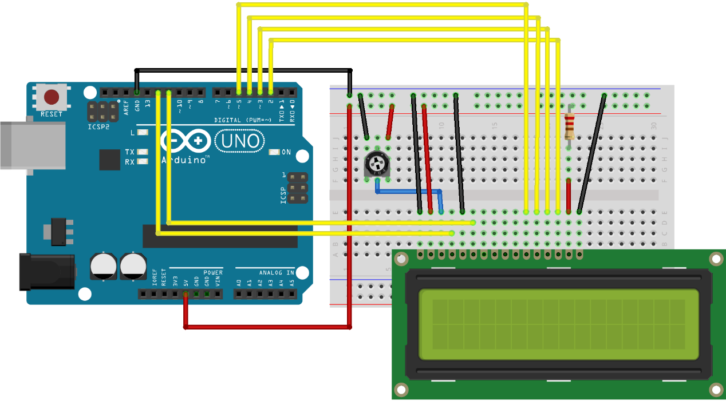
// 导入库
#include <dht11.h>
#include <LiquidCrystal.h>

// 初始化LCD库
const int rs = 12, en = 11, d4 = 5, d5 = 4, d6 = 3, d7 = 2;
LiquidCrystal lcd(rs, en, d4, d5, d6, d7);

dht11 DHT11;
#define DHT11PIN 8

void setup()
{
Serial.begin(9600);
// 设置LCD的行列数
lcd.begin(16, 2);
}

void loop()
{
lcd.clear();

// 显示湿度
lcd.print("Humidity:");
lcd.print(DHT11.humidity);
lcd.print("%");

//换行
lcd.setCursor(0, 1);

// 显示温度
lcd.print("Temperature:");
lcd.print(DHT11.temperature);
lcd.print("C");

delay(2000);
}

