抢答器
当按键按下时，数字10、9、8接口可读出为高电平，这时我们使数字7、6、5口输出高电平可使小灯亮起，程序中我们判断数字10、9、8口是否为低电平，要为低电平使数字7、6、5口输出也为低电平，小灯不亮。

原理图
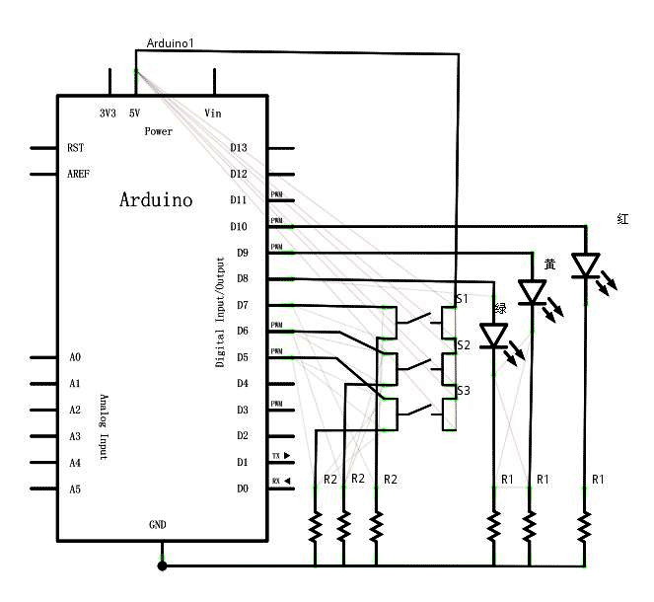

实物连接图
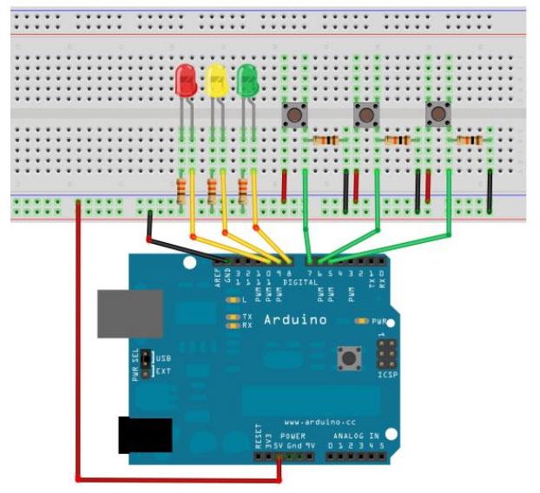

程序代码
int redled = 10;
int yellowled = 9;
int greenled = 8;
int redpin = 7;
int yellowpin = 6;
int greenpin = 5;
int red;
int yellow;
int green;
void setup()
{
pinMode(redled, OUTPUT);
pinMode(yellowled, OUTPUT);
pinMode(greenled, OUTPUT);
pinMode(redpin, INPUT);
pinMode(yellowpin, INPUT);
pinMode(greenpin, INPUT);
}
void loop()
{
red = digitalRead(redpin);
if (red == LOW)
{
digitalWrite(redled, LOW);
}
else
{
digitalWrite(redled, HIGH);
}
yellow = digitalRead(yellowpin);
if (yellow == LOW)
{
digitalWrite(yellowled, LOW);
}
else
{
digitalWrite(yellowled, HIGH);
}
green = digitalRead(greenpin);
if (green == LOW)
{
digitalWrite(greenled, LOW);
}
else
{
digitalWrite(greenled, HIGH);
}
}

